**BEEE Evaluation**

**Aim:** To make automatic led diwali lights (consisting of 6 leds) such that it only works during night and can generate two patterns which can be toggled with a switch.

1. Pattern 1- led chaser.
2. Pattern 2- even-odd led’s

**Apparatus:** LEDs, Resistances (470 Ω, 10 KΩ, 50Ω), Breadboard, Arduino, wires, push button, ldr(light dependent resistance).

**Circuit Diagram:**

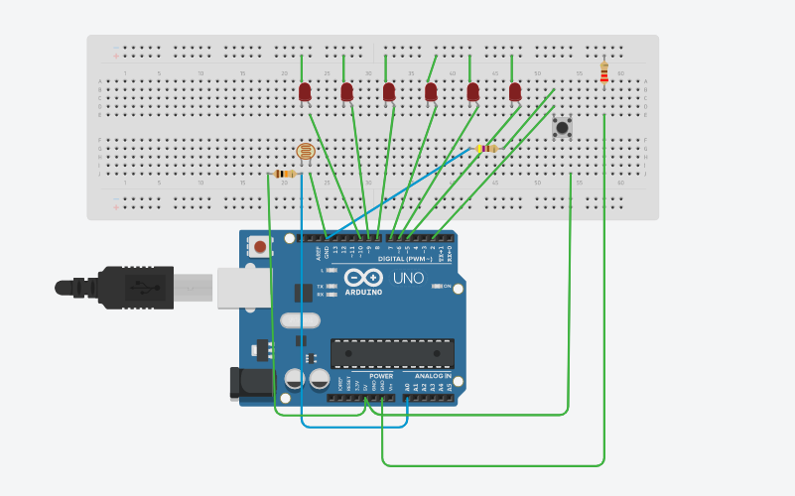

**Theory:**

1. Concept Used:
2. Current flows from anode to cathode and not in reverse direction through LEDs.
3. In Arduino, digital pins provide input as well as output but analog pins only provide input.
4. Connections inside push button.
5. Resistance of LDR decreases with increasing incident light intensity.
6. Resistance is used in series with LEDs to oppose current so that excess current may not damage LED.
7. Learning & Observations:
8. Learn to Join LEDs in parallel.
9. Learn about different parts of Arduino and how to use them.
10. Learn use of LDR and switch to give supply.
11. Use of resistance with LDR and push button.
12. All anode parts of LEDs are connected to digital pins of Arduino.
13. All LEDs are ending at a single point before connecting to Arduino.

**Problems and Troubleshooting:**

1. Using ‘for’ loop. It is solved by learning basics about ‘for’ loop.
2. There were many errors in program. These were solved by analyzing and finding mistakes.
3. Changing patterns using switch. It is solved by making different programs.
4. We do not know about connections of push button. It is solved by learning more about push button.

**Precautions:**

1. Use resistance with LDR and push button.
2. Connections should be made carefully and clearly.
3. ‘for’ loop, ‘If-else’ and nested if-else should be used carefully.
4. Take care while making connections through switch.
5. Give some delay time between ‘on’ and ‘off’ states of LED to distinguish.
6. We should use resistance so that excess current may not damage any LED.

**Learning Outcomes:**

1. Using Arduino for making different kinds of LED patterns.
2. Using ‘for’ loop, ‘if-else’ and nested if-else properly.
3. Defining new functions like void allLEDsOff (void).
4. Using functions like serial.begin, serial.print etc.
5. Principle and theory about LDR and Arduino.
6. Using Arduino and defining output pins.
7. How connections are made inside a breadboard and in push button.
8. Using void setup and void loop.

**Result:** Automatic lights working during night and generating two patterns controlled through switched is observed after running Arduino.